**RESEARCH INTERNSHIP CERTIFICATE**

This is to certify that internship report entitled **“Binary Class Coyote Optimisation Algorithm with Levy Flight Mechanism for Feature Selection”**, funded by **Department of Science & Technology** for project titled **“Detection of life threatening diseases by examining the human genome in Microarray data using distributed implementation of algorithms”**, done by **Aditi Gulati** ; **Roll No. 02101012021**, student of **“ 1st Year, CSE-1 ”**, is submitted to **Indira Gandhi Delhi Technical University for Women**, carried out at IGDTUW is accepted in terms of quality and the work has been done under my supervision and guidance from **01-02-2022 to 31-05-2022** and is a record of the bonafide work done successfully. This report is prepared for her academic requirement related to Research internship training and Research paper is submitted to Journal. **The plagiarism of this internship report is less than 10%.**

**Date: 31-05-2022**

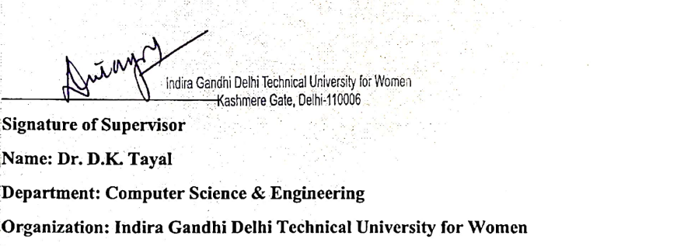

**SUMMER INTERNSHIP CERTIFICATE**

This is to certify that internship report entitled **“Evaluating Inconsistency in Textual and Speech Sentiments”**, done by **Aditi Gulati** ; **Roll No. 02101012021**, student of **“ 2nd sem, CSE-1”**, is submitted to **Indira Gandhi Delhi Technical University for Women**, carried out at IGDTUW is accepted in terms of quality and the work has been done under my supervision and guidance from **01-06-2022 to 31-08-2022** and is a record of the bonafide work done successfully. This report is prepared for her academic requirement related to summer research internship training and Research paper is submitted to Journal. **The plagiarism of this internship report is less than 10%.**

**Date: 31-08-2022**

